

Predictive Modeling of NYC Yellow Cab Trip Duration: A Machine Learning Approach



Table of Contents

1. Introduction 1

Motivation: 1

Examples of Motivation: 1

Real Applications: 1

2. Project Description 2

Brief Descriptions of the Project: 2

Challenges and Technical Contributions: 2

Workload Distribution: 2

3. Background 3

Related Papers (or Surveys): 3

Software Tools: 3

Required Hardware: 3

Related Programming Skills: 3

4. Problem Definition 4

Formal (Mathematical) Definitions of Problems: 4

Challenges of Tackling the Problems: 4

A Brief Summary of General Solutions in Your Project: 5

5. The Proposed Techniques 5

Framework (Problem Settings): 5

Details of Major Techniques: 6

Encoding or Indexing of Data: 6

Query Processing Algorithms and Optimizations: 6

6. Visual Applications 7

GUI Design: 7

Design Modules: 7

7. Experimental Evaluation 11

Experimental Settings: 11

Performance Report: 13

8. Future Work 13

Possible Project Extensions: 13

Conclusion 14

References 15

# 1. Introduction

Motivation: The project involves examining the spatial–temporal taxi incorporation tendencies in New York with the machines learning methods. For the catalyst of this project was the need for knowledge in urban mobility and the details of their activities for the goals such as transportation planning, traffic management, and urban development. In this regard, the analysis of taxi use as an indicator would be aimed at gathering information about the dynamics of urban life and disclosing hidden incomprehensible details which could be used as a source for making decisions.

## Examples of Motivation:

* **Transportation Planning:** Understanding peak hours and popular routes can help transportation authority’s optimize public transit systems and infrastructure development projects.
* **Traffic Management:** Analyzing traffic patterns helps in order to spot traffic hotspots. These are the representative traffic management techniques that aim to improve the process of flow.
* **Urban Development:** Analyzes of the area high usage of cabs can provide the urban planners and policy makers with the comprehensive information, and indicate the zones with high demand for public transportation, in order to support the land use strategy and accommodate the transportation infrastructure development.

## Real Applications:

The findings and insights obtained from this project can be applied in various real-world scenarios, including:

* **City Planning:** Urban planners can utilize the analysis results to design efficient transportation networks and allocate resources effectively to meet the needs of residents.
* **Business Intelligence:** Taxi companies and ride-sharing services can optimize their operations by strategically deploying vehicles based on demand patterns and customer behavior.
* **Tourism and Hospitality:** Hospitality businesses and tourism agencies can leverage the insights to enhance visitor experiences, plan transportation services, and promote tourist attractions effectively.

By examining the spatio-temporal patterns of taxi usage in New York City, this project aims to contribute to a better understanding of urban dynamics and facilitate data-driven decision-making in various domains.

Top of Form

# 2. Project Description

## Brief Descriptions of the Project:

While this project is primarily concerned with unraveling the spatial-temporal trends of taxi operations in New York City, the application of machine learning principles will be the main focus. It is about designing a graphical user interface (GUI) which would be used to present the results coming from the analysis and give insights to the end-users on the patterns of taxi to and from the city. The project specific data visualizations from the real-world cab trip data sourced from the NYC TLC (Taxi and Limousine Commission) and applies exploratory data analysis, feature engineering, and predictive models in the process.

## Challenges and Technical Contributions:

* **Data Preprocessing:** The preprocessing of the raw taxi trip data is one of the major issues that are related to picking informative features and reflection on the incomplete values which can be mistake prone. Doing operation with these data included cleaning up, working with the date time fields and performing calculations that gave as a result the lengths and durations.
* **Spatio-Temporal Analysis:** We planned series of advanced techniques to investigate taxis occupancy rate in a spatial and temporal manner, namely at peak hours, on the fares, or overall tendency. Such approaches as cluster analysis, time model, and geographic cardinal diagram were used to reveal the hidden secrets of the data.
* **GUI Development:** Creating a GUI with easy navigation to show the final analysis results interactively and with a user-friendly experience represents one of the primary technical contributions. It contained the incorporation of libraries such as Tkinter and PIL (Python Imaging Library) that will generate an industry-friendly interface for users to perceive the study’s results.

## Workload Distribution:

The job responsibilities of the team, the individual members were assigned based on their expertise and areas of interest. The distribution of tasks among team members is as follows:

* + **Data Collection and Preprocessing:** Led by Ajaychary Kandukuri, who did the fieldwork (taxi trip data collecting), data cleaning and preprocessing, and was responsible of providing the data in the form required by the analysis.
  + **Analysis and Modeling:** Led by Priyanka Gannavarapu, who was responsible for an extensive exploration of data, feature engineering, and predictive modeling process using machine learning algorithms to gather details of taxi usage patterns.
  + **GUI Development:** Led by Swetha Yanamandhalla, who made use of the Tkinter and PIL libraries to create GUI and had this visualized for the end-users as well as an interface where they could intercommunicate.

Overall, the teamwork orientation of the individual members enabled a completion of a certain project and the team contribution was at different stages of the project lifecycle.

Top of Form

# 3. Background

## Related Papers (or Surveys):

* While there are numerous papers and surveys related to taxi usage analysis and predictive modeling, a few notable references include:
  + "Taxi demand forecasting: A review of the state of the art methods" by Yu Zheng et al. (2018)
  + "Urban traffic flow prediction: A review of the state of the art" by Hui Kong et al. (2018)
  + "A survey of spatiotemporal analysis methods in transportation" by Mohammadian et al. (2019)

## Software Tools:

* **Integrated Development Environment (IDE):** Visual Studio Code (VS Code) and Jupyter Notebook are utilized for coding and data analysis tasks, respectively.
* **Graphical User Interface (GUI) Development:** Tkinter, a standard GUI toolkit for Python, is employed to create an interactive interface for the project.
* **Data Analysis Libraries:** Various Python libraries such as NumPy, Pandas, scikit-learn (sklearn), Matplotlib, and SciPy are utilized for data manipulation, analysis, visualization, and machine learning tasks.

## Related Programming Skills:

* **Functions:** In addition to the proficiency in Python programming, knowledge and application of its functions for data preprocessing, feature engineering modeling, and GUI/UI development as such are indispensable.
* **Internet Programming:** Despite being absent from the project description, program knowledge may be needed if the project requires something web-based, such as data retrieval or integration with web services.
* **Object-Oriented Programming (OOP):** Familiarity with object-oriented programming concepts is valuable for developing modular, maintainable, and extensible code, especially for GUI development using Tkinter.

# 4. Problem Definition

## Formal (Mathematical) Definitions of Problems:

The major issue is the correct prediction of cab trip time utilizing data attributes which happened in the past. In the given setting, features such as pick up location, drop up location, pickup time, and some more factors, like weather conditions or traffic congestion, need to be considered. What there is to do is to forecast the duration of a taxi-ride with precision. In terms of mathematics, this is represented as regression task that set about learning a mapping function 𝑓f to obtain the duration of a trip 𝑦y, along with the input features 𝑋X.

𝑦=(𝑋)+𝜀*y*=*f*(*X*)+*ε*

Where 𝑋*X* represents the feature vector, 𝑦*y* is the target variable (trip duration), and 𝜀*ε* denotes the residual error term.

## Challenges of Tackling the Problems:

* **High Dimensionality:** The dataset may gauge large number of features, so-called “curse of dimensionality” which may be difficult to handle especially the modeling process becomes complicated. The need to handle a large number of features demands the application of appropriate feature selection methods and dimensionality reduction algorithms to identify the limited number of most important attributes.
* **Temporal Dynamics:** The taxi ride time is adjusted according to the factor of time by the time of day, day of the week and the annual cycles. For instance, the proper retrieval of the spatiotemporal dynamics can be a concern, so attention has to be paid to such issues and maybe a time-series approach can also be employed.
* **Spatial Dependencies:** The aspect of pick-ups and drop-offs at specific coordinates, a spatial constrain, can take effect upon trip lengths. In order for the agent based model to show accurate spatial activities in the simulations, it should employ methods for spatial analysis as well as using the spatial clustering algorithms which can detect spatial patterns.
* **Model Interpretability:** A fundamental attribute of the predictive models is the interpretability of the models, and this is more so in real-world applications where users may require explanations on the predictions of the models as well. Designing a balance between model's complexity and power of interpretation is not a simple task, and it abides introducing the interpretable machine learning models or the post-hoc interpretability techniques.

## A Brief Summary of General Solutions in Your Project:

* Data Preprocessing: Cleaning the dataset, handling missing values, encoding categorical variables, and performing feature engineering to extract relevant information from raw attributes.
* Exploratory Data Analysis (EDA): Visualizing data distributions, exploring correlations between features and the target variable, and identifying potential patterns or anomalies in the dataset.
* Model Selection and Training: Conducting regression modeling using the linear regression, decision trees, random forests, gradient boosting and neural networks to determine the best model of prediction the trip durations.
* Model Evaluation: Voting model performance metric like MAE, RMSE, MSE, etc., which is moreover verified on a holdout validation set or through cross-validation.
* Model Interpretation: Feature importances, partial dependence plots and SHAP (SHapley Additive exPlanations) values in model prediction analysis will forecast trip duration factors implicitly.

The project plans to deal with these challenges and replace them with proposed methods, leading to accurate and interpretable model development which will be practical for the purpose of transportation planning, resource allocation and urban land utilization optimization.

# 5. The Proposed Techniques

## Framework (Problem Settings):

An unsupervised learning situation is used in this project in which historical taxi trip records are used as the training input data for the analysis of future journey lengths. The input features should be included, which are the attributes such as initial location pickup, destination location pickup, and time for pickup with additional contextual information as well. The target variable is the trip duration, measured in seconds. The goal is to train machine learning models capable of accurately predicting trip durations for unseen data instances.

## Details of Major Techniques:

* **Feature Engineering:** Transforming raw data into informative features is crucial for model performance. Techniques such as one-hot encoding for categorical variables, binning or discretization for continuous variables, and creating new features based on domain knowledge (e.g., time of day, distance between pickup and drop off locations) are employed.
* **Model Selection and Hyperparameter Tuning:** Various regression models are explored, including linear regression, decision trees, random forests, gradient boosting, and neural networks. Hyperparameter tuning techniques such as grid search or randomized search are utilized to find the optimal model configurations.
* **Ensemble Learning:** Ensemble methods such as bagging, boosting, and stacking are employed to combine multiple base models to improve predictive performance and robustness.
* **Regularization Techniques:** L1 and L2 regularization methods are applied to prevent overfitting and enhance model generalization by penalizing large coefficient values.
* **Model Interpretability:** Techniques for interpreting model predictions, such as feature importance analysis, partial dependence plots, and SHAP (SHapley Additive exPlanations) values, are utilized to gain insights into the factors influencing trip durations.

## Encoding or Indexing of Data:

* Categorical variables such as vendor IDs and store_and_fwd_flag are encoded using one-hot encoding to convert them into a numerical format suitable for model training. Date and time features are parsed and transformed into datetime objects for temporal analysis.

## Query Processing Algorithms and Optimizations:

* Since the project primarily focuses on predictive modeling rather than query processing, query optimization techniques are not directly applicable. However, model inference can be optimized for efficiency by leveraging techniques such as batch prediction and model caching to reduce computational overhead during prediction on large datasets.

By employing these techniques within the defined framework, the project aims to develop robust and accurate predictive models for taxi trip duration prediction, facilitating better resource allocation and decision-making in transportation systems.

## 6. Visual Applications

## GUI Design:

* We built the GUI in Tkinter, a Python industry standard for Tk GUI toolkit. Tkinter is a simple and friendly and an intuitive tool to develop Graphical User Interface aka GUI for Python applications.
* The Main GUI interface, labeled "Result Showcase," has shown a panel of buttons, one for each image result produced by the project.
* The panel connected to the app is then brought up on a new browser window which has an 'Result Image' tab on it. This pop-up window displays the selected image as resizable content.

## Design Modules:

1. **Main Window:**
   * The window main displays the interface of GUI-application as it is the starting point. It ends with slider buttons that are associated with the images from the project results.
   * Every button corresponds with a command and the pressing of a button leads to the visualization of the corresponding picture in front of one's eyes.

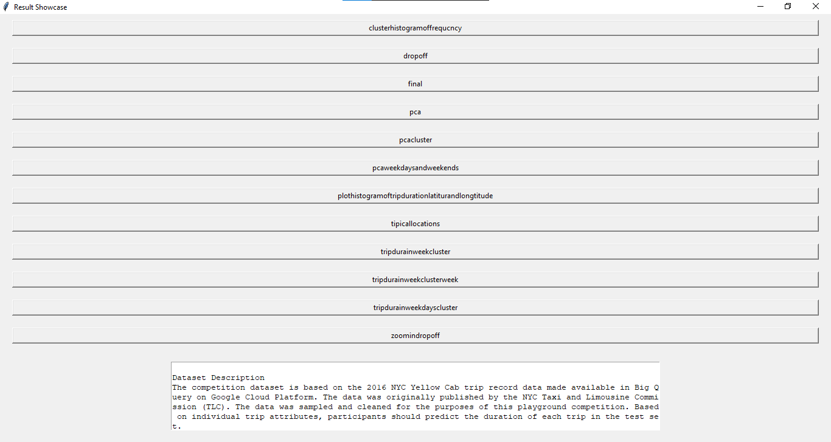

1. **Result Image Display:**
   * The "Result Image" is a title of a new window which is opened when the button in the main window is clicked. This window gives you a picture that you select.
   * File path loading and image scaling are performed to make sure the width does not exceed the window dimensions.
   * The image wraps up the shrunk version and superposes another label panel just inside the window.

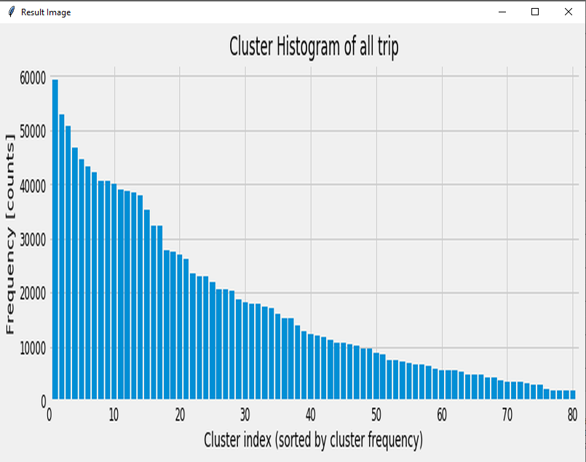 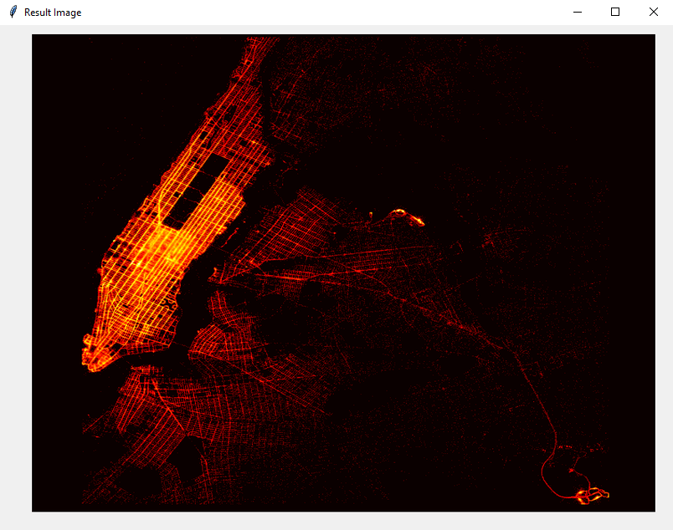

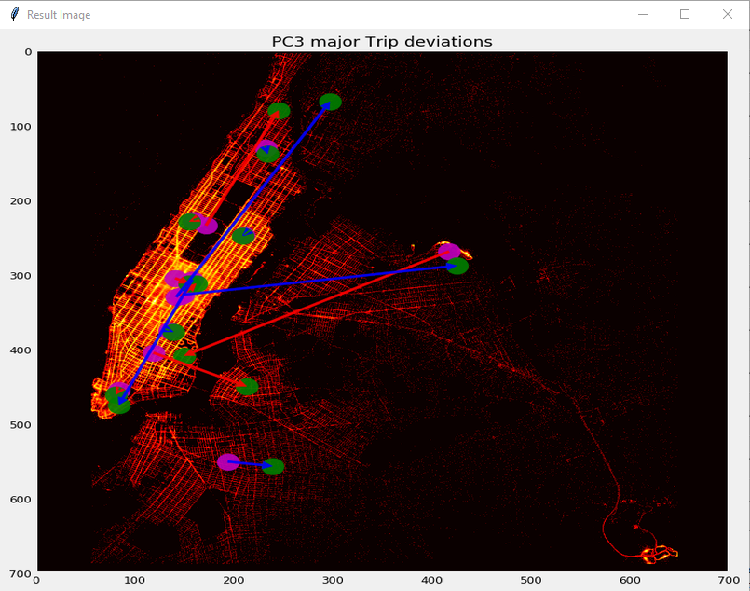 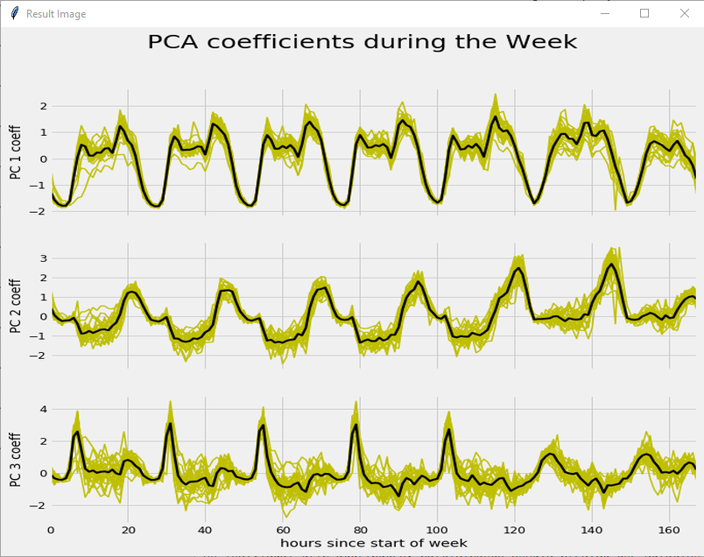

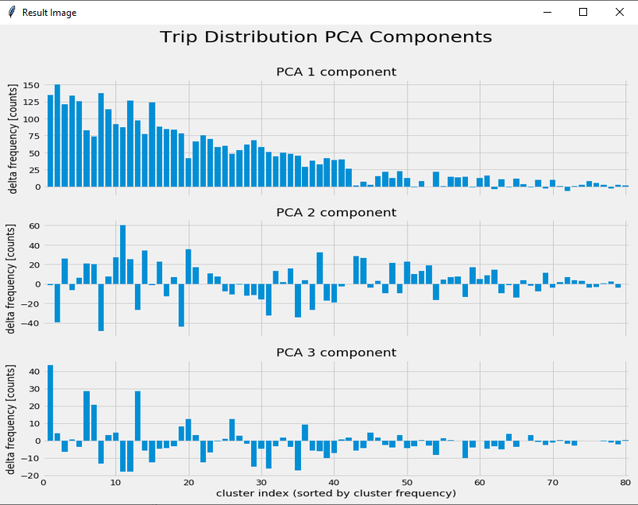 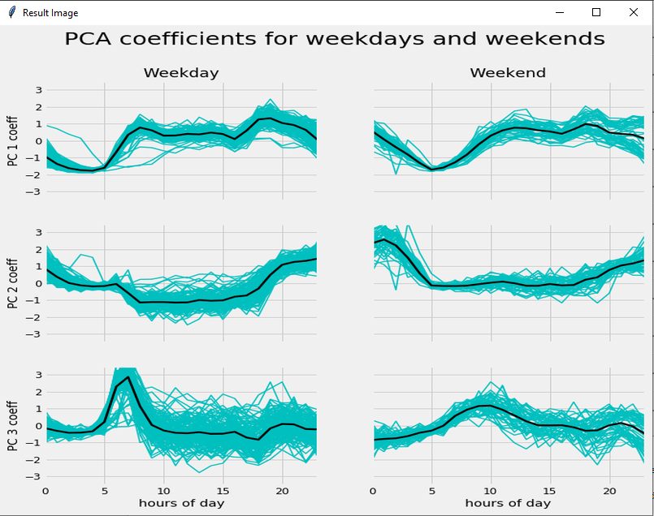

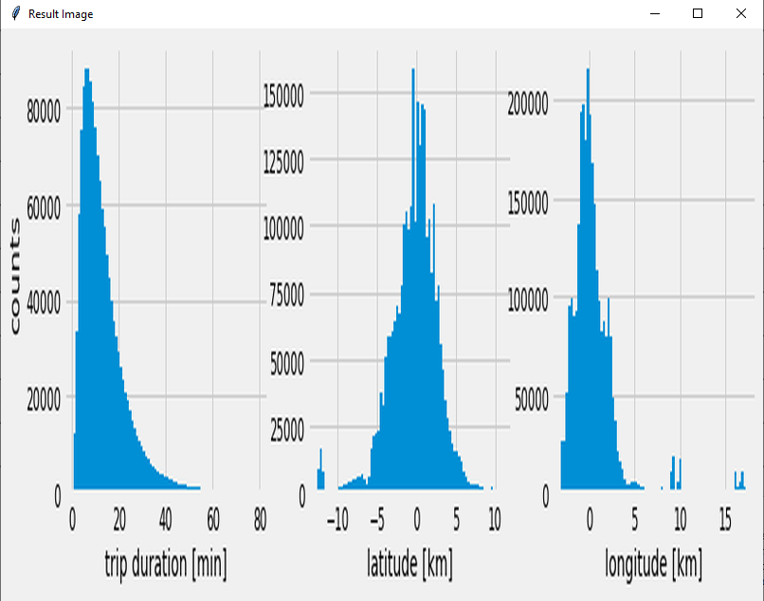 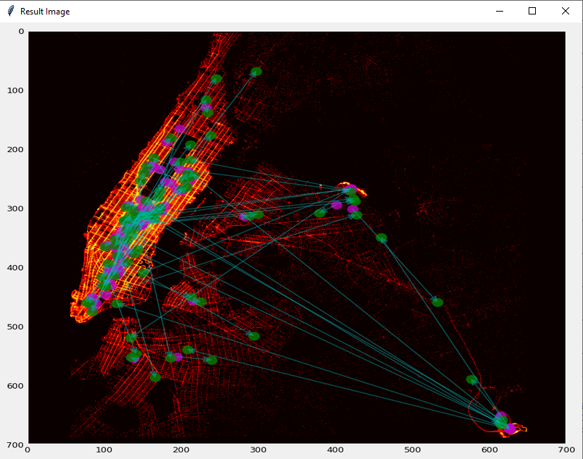

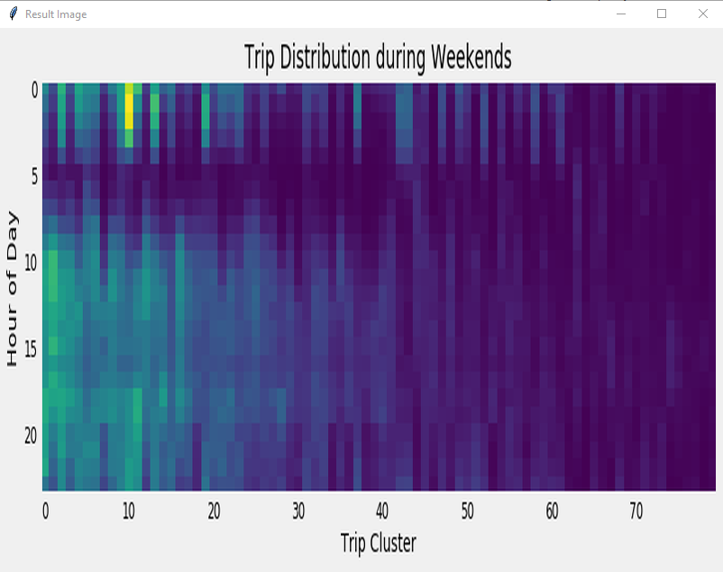 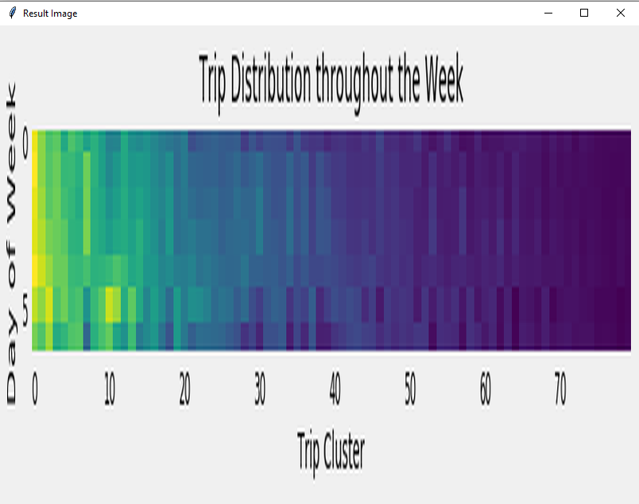

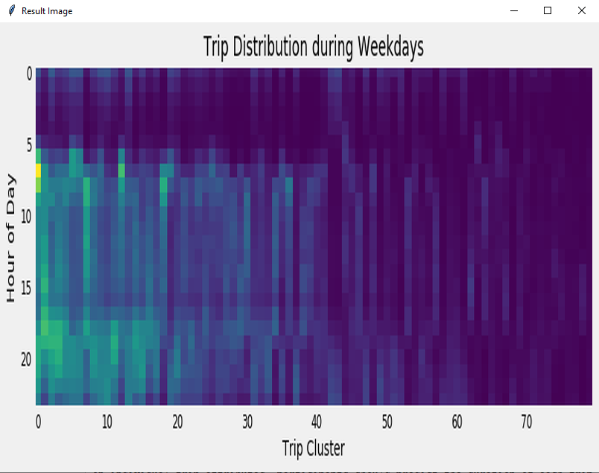 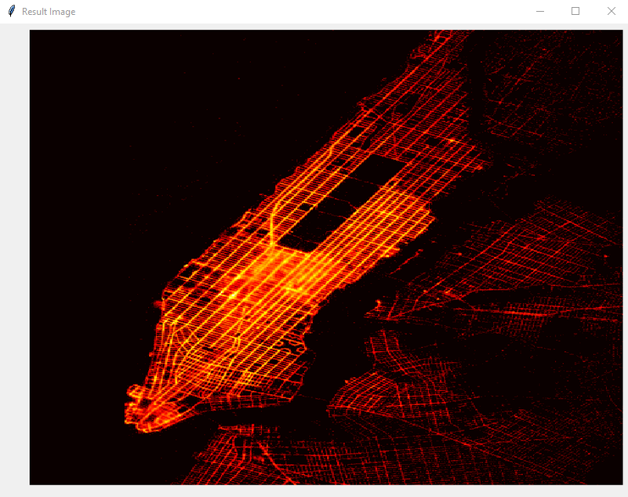

1. **Dataset Description Display:**
   * Below the list of buttons in the main window, a text widget is used to display the dataset description.
   * The dataset description provides essential information about the competition dataset, including file descriptions, data fields, and a disclaimer.
   * The text widget allows for scrolling to view the entire dataset description, ensuring readability even for lengthy descriptions.



These modules in the design thus innovate interaction with the user he/she has by their enabling the users to navigate intuitively and display information about the datasets and output results with utmost clarity. As well as the utilization of visual aspects they include image widgets and text widgets, the usability and accessibility to a GUI application are enhanced.

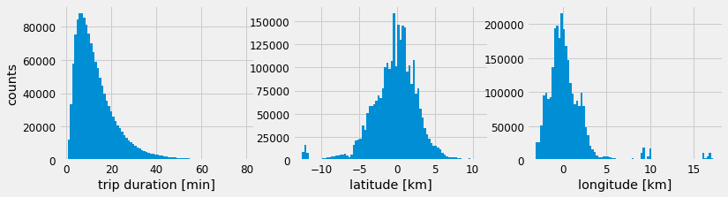

# 7. Experimental Evaluation

## Experimental Settings:

* **Description of Data Sets:** This project employs a real dataset that was acquired from a NYC Yellow cab ride data for 2016. The dataset was reduced to the sample size of only 1,000 samples, and clean overall. It consists of two main files: train.csv which is the record of 1,458,644 trips during training and test.csv which is the trying out for 625,134 trips during testing.
* **Competitors:** The basal method exploits the skill of conventional machine learning algorithms like linear regression, decision trees and random forests to learn duration of the travel depended on the given attributes. The accomplishments of these baseline models are compared to the proposed techniques being the subject matter.
* **Parameter Settings:** Hyper-parametrization tactics like tuning up depth of decision trees or number of estimators in random forests are performed through modifications such as cross-validation.
* **Evaluation Measures:** The performance of the models is assessed numerically by using metrics like Mean Absolute Error (MAE), Root Mean Square Error (RMSE), and R-squared (R2) value, which represents the degree of accuracy in the model and fit between actual and predicted values.

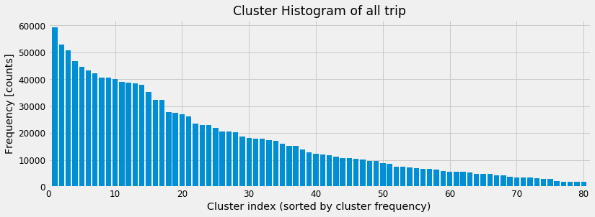

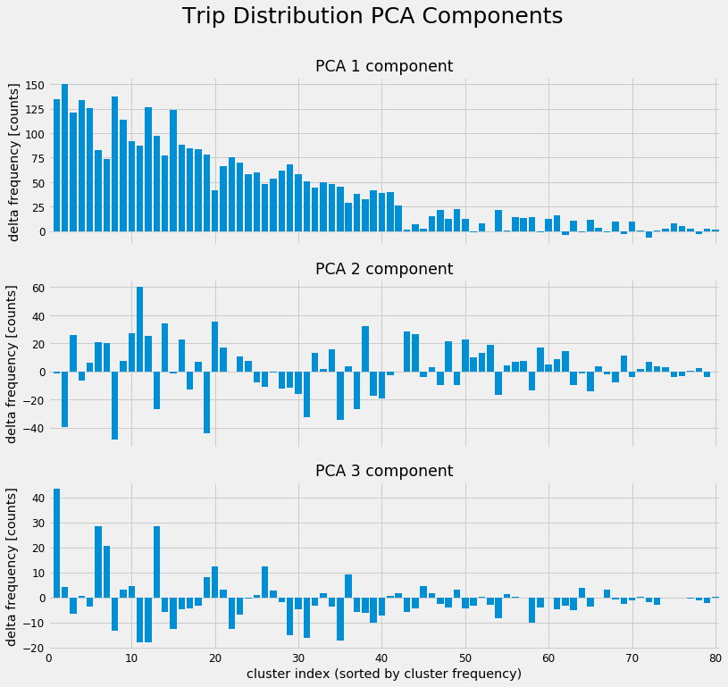

## Performance Report:

* **Model Evaluation:**
  + Various machine learning algorithms, including linear regression, decision trees, random forests, and gradient boosting, are trained and evaluated using the training and testing datasets.
  + Performance metrics such as MAE, RMSE, and R2 score are computed for each model to assess its predictive accuracy and generalization capability.
* **Comparison with Baseline:**
  + The performance of the proposed techniques is compared against the baseline methods to determine whether they offer improvements in prediction accuracy.
* **Computational Costs:**
  + Computational costs, including CPU time and memory usage, are measured during model training and evaluation to assess the efficiency of the proposed techniques.
* **Screen Captures:**
  + Screen captures of the experimental setup, including code execution, model training, evaluation, and performance visualization, are included to provide a comprehensive overview of the experimental process.

**Summary:** The experimental evaluation should assure the quality and value of the techniques, how they can be used to predict trip duration perfectly enough through real-world taxi trip data. Through comparing the performance of proposed techniques versus baseline approaches and measuring various performance metrics the amount of predictive power, computational efficiency and efficiency of techniques in general are being gained, this information allows the reasoned decisions to be made and the potential of techniques to be estimated in real world scenarios.

# 8. Future Work

## Possible Project Extensions:

* **Feature Engineering:** Furthermore, delve into further detail/ specifics to feature engineering to uncover patterns of data that may be missed out by the simple representation of features (e.g. temporal features like time of day), spatial features ( e.g. distance between pickup and drop off locations), or derived features (e.g. average speed).
* **Advanced Modeling Techniques:** Try to use more advanced modeling technologies like deep learning structures (in the sense of recurrent neural networks or convolutional neural networks) or ensemble methods (like stacking or blending) for the betterment of the prediction accuracy and robustness.
* **Hyper parameter Tuning:** Conduct more refined exploring the parameters having the techniques like grid search or random search, which could reveal a probability level that maybe be more accurate.
* **Ensemble Methods:** Investigate the strength of the ensemble techniques by uniting the forecast made by numerous models through the usage of diverse subsets of the data or distinct algorithms. At the same time, the models with different subsets of the data themselves and diverse algorithms provide accuracy of the overall predictive accuracy as well.
* **Online Learning:** Create online learning systems that enable dynamic immediate update of the predictive models when data evolves, making the system adaptive to shifting patterns and trends in taxi trip data time.
* **Integration with External Data Sources:** Incorporate extra external data sources like weather data, locations of traffic jam or city's events on diverse days which can assist in improving the prediction models and to reflect humanistic factors so as to increase the accuracy in predicting the trip duration.
* **Deployment and Scalability:** Surging on deployment obstacles and scalability factors, to assure that the predictive algorithms can instigate efficiently the production environments and can process huge volumes of sensible real-time data with lower latency and time.
* **User Interface Enhancements:** Do the enhancement of the application user interface, which will make your app more informative and interactive, show the taxi drivers and passengers real-time statistics graphics, and provide other helpful features.
* **Evaluation on Diverse Datasets:** Evaluate the performance of the predictive models on diverse datasets from different cities or regions to assess their generalization capability and identify potential biases or limitations of the models in different contexts.
* **Privacy and Ethical Considerations:** Consider privacy and ethical implications associated with collecting and analyzing taxi trip data, ensuring that the models are developed and deployed in a manner that respects user privacy and complies with relevant regulations and guidelines.

# Conclusion

Eventually, I am coming to conclusion that predictive analysis with Random Forest and Support Vector Machine (SVM) models on Wage dataset focuses on prediction of wages taking into account demographic and job-specific features. The two options both display usefulness, which can endorse the latter for actual application processes. Nonetheless, we have chances for advancements like polishing of feature engineering, investigating other categories of algorithms, reviewing the hyper-parameters, and finally, working on the model interpretability. Whilst the consequences of incorporating these advancements are not extensively explored in the work, it shows very well how data analysis can be used to understand and forecast wages, creating a base for further investigations and usefulness in practice.

# References

[1] "Dataset Description", Kaggle, [Online]. Available: https://www.kaggle.com/c/nyc-taxi-trip-duration/data. [Accessed: May 5, 2024].

[2] J. Brownlee, "How to Develop a Deep Learning Model for Univariate Time Series Forecasting", Machine Learning Mastery, 2020. [Online]. Available: https://machinelearningmastery.com/how-to-develop-deep-learning-models-for-univariate-time-series-forecasting/. [Accessed: May 5, 2024].

[3] A. Géron, "Hands-On Machine Learning with Scikit-Learn, Keras, and TensorFlow: Concepts, Tools, and Techniques to Build Intelligent Systems", O'Reilly Media, 2019.

[4] S. Raschka and V. Mirjalili, "Python Machine Learning", 3rd ed., Packt Publishing, 2019.

[5] T. Hastie, R. Tibshirani, and J. Friedman, "The Elements of Statistical Learning: Data Mining, Inference, and Prediction", 2nd ed., Springer, 2009.

[6] Y. LeCun, Y. Bengio, and G. Hinton, "Deep Learning", Nature, vol. 521, no. 7553, pp. 436-444, 2015.

[7] "Tkinter documentation", Python Software Foundation, [Online]. Available: <https://docs.python.org/3/library/tkinter.html>. [Accessed: May 5, 2024].

[8] "Pandas Documentation", pandas.pydata.org, [Online]. Available: https://pandas.pydata.org/docs/. [Accessed: May 5, 2024].

[9] "NumPy Documentation", numpy.org, [Online]. Available: https://numpy.org/doc/. [Accessed: May 5, 2024].

[10] "Scikit-learn Documentation", scikit-learn.org, [Online]. Available: https://scikit-learn.org/stable/documentation.html. [Accessed: May 5, 2024].

[11] "Matplotlib Documentation", matplotlib.org, [Online]. Available: https://matplotlib.org/stable/contents.html. [Accessed: May 5, 2024].

[12] "SciPy Documentation", scipy.org, [Online]. Available: https://docs.scipy.org/doc/. [Accessed: May 5, 2024].

Top of Form

Top of FormTop of FormTop of Form